"This Is the Day the Lord Has Made":
Clara Andonian's Story of Faith and Service

Journeys of Faith, Survival, and New Beginnings Series

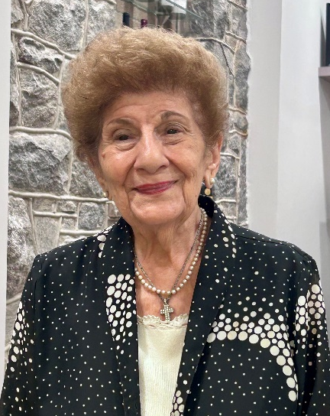
Clara Andonian’s family story is a testament to the faith, courage, and hard work that carried Armenian families from the tragedy of genocide to the promise of a new life in the United States. Through memories of her family’s service and devotion to God, Clara recounts not only her family’s journey but also the story of a generation that helped build St. Mary’s Armenian Apostolic Church and laid the foundation for the community we cherish today. Her story reminds us that the faith and sacrifices of one generation become the blessings and hope of the next.
Clara Andonian, 2026.

CLICK HERE TO READ THE FULL STORY:

Below is an edited transcript of the interview with Clara Koharig Najarian Andonian, conducted and recorded by Anna Amirkhanyan on June 20, 2026. Unless otherwise indicated, all photographs are from Clara’s family archive. The spellings of historic locations have been adopted from Clara’s records.

Anna: Clara, can you tell me the story of how your family came to America and what circumstances led them to leave their homeland?

Clara: In 1915, during the Armenian Genocide, my mother, Pyloon, and my father, Harutoon, were living in Harpoot. My mother was three years old, and my father was five, when the genocide started. My grandmother had to give my mother to the missionaries who were coming through to take the children to safety. My mother went with the German missionary group. (My father was with the American one. There were also Danish and Catholic missions.) Fräulein Von Baronoff, a Baltic noblewoman and benefactor, funded the German missionaries, who ran a Maranatha home in Mezire for approximately 150 Armenian girls. The missionaries took the children, including my mother, from historic Armenia all the way to Aleppo, Syria. There, when my mother was 10 years old, she saw the death march in front of her. Their Mayrapet [House Mother – A.A.] had said to the children, “Who wants to give up their pail of water for these people?” And my mother said, “I will give my water up,” and she gave it to a husband and wife who were in the line. The couple blessed her many times, saying, “Your life is going to be blessed because you saved us.”
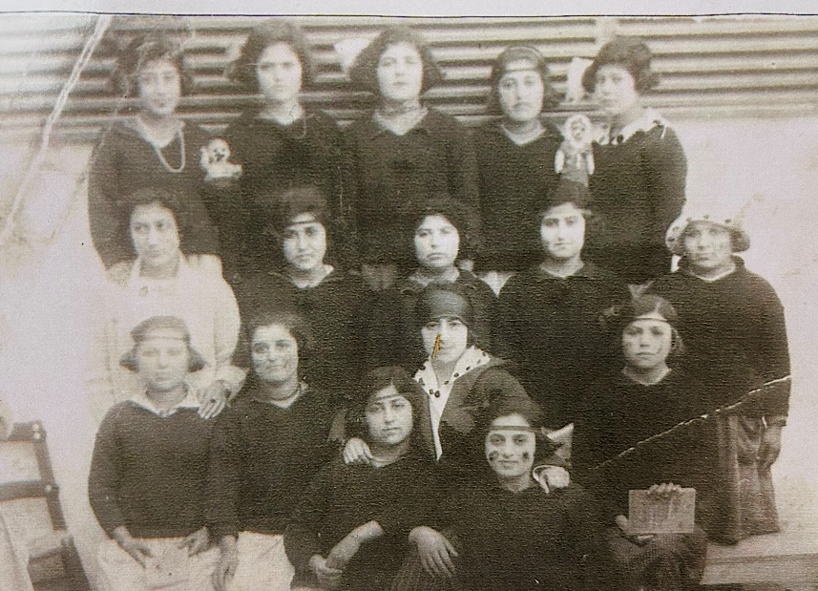
Clara’s mother, Pyloon (top row, third from left), while with German missionaries.

Over this 10-year period, the missionaries took the children all the way to Greece, and later brought them down to Beirut, Lebanon. In Beirut, the missionaries recorded the children's names on a roster to help families identify their loved ones. My mother’s babysitter at the mission knew my mother’s family well; she knew that my mother was a Manoogian and had a birthmark on the side of her neck. So, when my grandmother also arrived in Beirut, she was able to find my mother’s name on the roster.
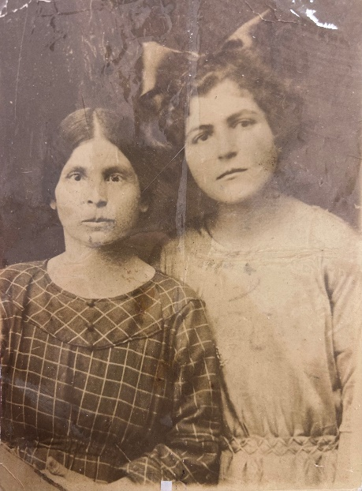
Left to right: Clara’s grandmother and mother, Pyloon, in Beirut, 1925.
Of course, at that time, my mother did not really know my grandmother. She wanted to go to Germany with her teacher, but my grandmother convinced her to leave the mission. My mother had been with the missionaries from the age of three until she was ten, and here is her photograph, taken in 2025 when she was reunited with my grandmother.

My maternal grandfather had been in the brass business in Harpoot. He would polish the brass and all the instruments and things for the church. After living through the 1896 Hamidian Massacres, my grandfather had come to America to raise money and send it back to help his family. My mother was only one year old when her father came to America and settled in Binghamton, New York.

I believe the Near East Relief Orphanage helped my grandparents communicate during that time. After my grandmother found my mother in Beirut, she was able to send a message to her husband that the child they had believed was dead was, in fact, alive. My grandfather was very happy to hear that! My mother had siblings, but none of them survived. Eventually, my grandmother and my mother, along with all the other relatives -- their cousins and other families from Harpoot -- went up to Marseille, where they took a ship to America.

When their ship reached Ellis Island, the U.S. immigration quotas turned out to be filled for that year, so they were not allowed to come into the country. Instead, they had to take a ship all the way down to Cuba, and that is where they lived for the next two years. My grandfather took the train from Binghamton, New York, where he was living, down to Key West and on to Cuba, where he finally met his family. In Cuba, my mother went to school and learned Spanish. She was happy to be with her mother once again. She was well educated and would write all the letters for people who had loved ones in America. Later on, when she was in Miami, she would jokingly tell her Spanish speaking friends, “I know your language, but you don't know mine!”

Two years later, my mother, grandmother, and all the relatives were finally able to move to the United States. As they traveled up from Florida to Binghamton, their train stopped in sunny Ocala, Florida, to pick up the mail -- the trains always picked up mail along the way. Some relatives asked if the weather was like that all the time, and when they heard “yes,” half the relatives got off and ended up owning cabbage and onion farms and property in Florida. The rest, including my mother and grandmother, went on to Binghamton.

My mother’s Armenian name was Pyloon. She liked to say, “My name is Pyloon, and I eat matsoon, and I go to the moon!” In America, however, she went by the name Helen.

This is my mother’s story of coming here.

My father, Harutoon, and his family were also living in Harpoot. My mother’s and father’s families were neighbors and were close. Whenever they made choreg [Armenian bread – A.A.], or whenever they undertook any big projects, they would all come together to do it. I was named after my paternal grandmother, Koharig. I guess I got my cooking abilities from her too! The Armenian community in Harpoot was quite large at the time. They had a church, and my grandfather was the treasurer of Soorp Garabed.

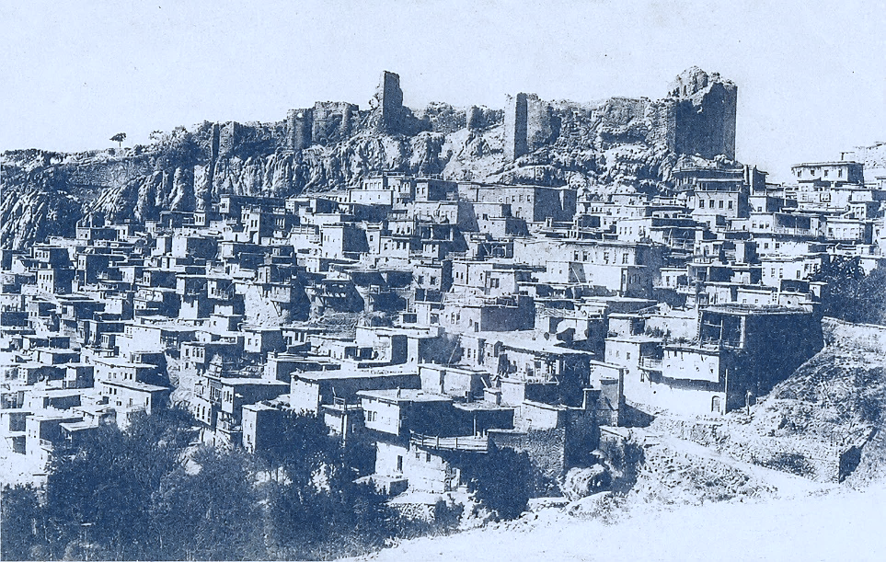
Harpoot, 19th Century
Source: https://massispost.com/2022/10/project-Harpoot-2022-historical-map-of-Harpoot-1914/

When my father came here by ship, he couldn’t come into Ellis Island because something was wrong with his eyes. Apparently, he had lain on his father's body when the massacre came, pretending to be dead, and this affected his eyes. His whole family perished - his father, mother and sisters. Only his brother, who was the oldest and the educated one, had left for America earlier and was sending money back to the family. So, my father was taken from Ellis Island to Rhode Island so his eyes could be treated. Later, his older brother Garabed, who was already in the States and was much older than my father, went up there and said, “That is my son” in order to bring him to America after they cured his eyes. So, they too ended up in Binghamton, among many other Kharperdsis. They stayed together!
In Binghamton, both my mother and my father worked in a shoe factory. My father would often take an apple and put it on my mother’s desk. Of course, he wanted to take her out, but it was forbidden for her to be alone with a man, so she had to take her friend with her whenever they went anywhere.

My parents got married on September 5, 1931 at St. Gregory the Illuminator Armenian Apostolic Church in Binghamton, NY. They moved to Washington, DC that year, and I was born on October 16, 1932.
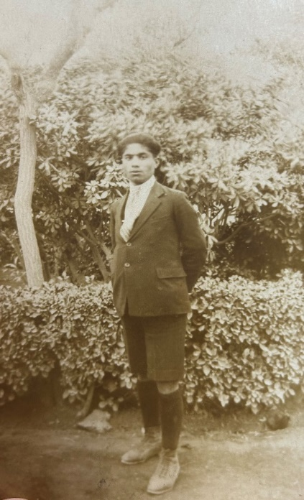
Clara’s father Harutoon, in Binghamton, NY, 1926.
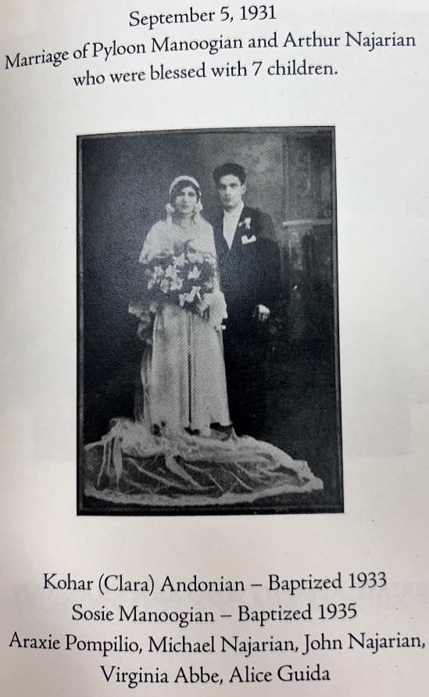
Clara’s parents, married at St. Gregory the Illuminator Armenian Apostolic Church, Binghamton, NY.
Growing up, I spent all my summers on the farm in Binghamton. At first, there was no running water there, but they eventually found it 10 feet deep. In fact, after I was born, my grandmother made 12 diapers from flour sacks for me, and she washed them in the first water they found. She said, “This baby will be very lucky because we found water today!” My family continued their involvement with St. Gregory the Illuminator Church, where I was baptized in 1933.

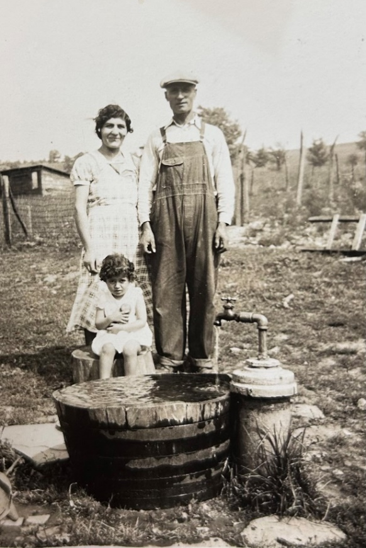
Clara’s mother and grandfather (top row) and Clara (sitting).

Around that time, my uncle had moved to Washington, D.C., where he went into the delicatessen business with his brother-in-law. They needed help, so my father also moved to Washington and joined them. Later, he struck out on his own and opened his own restaurant.

I was born in D.C. in the old Sibley Hospital on North Capitol Street. When I was born, my stay cost only 50 cents a day, and my mother’s was $1.50 a day. At that time, they kept you in the hospital for 10 days. I gave all the handouts that the hospital gave my mother -- the directions on how to take care of the baby and the vaccination records -- to the Sibley Hospital Historical Society to help preserve it. Sibley was a wonderful hospital!

My parents had five daughters and two sons, and I was their first child. I would be the one who brought them together and told them what they had to do. My mother would always want to play with us, and whatever we did, she made it fun. If you were baking a cake, she'd make it fun. Now, you count everything that she learned from the missionaries: how to bake, how to sing, how to recite, and how to scrub a floor. We had none of the facilities that we have today to make life so much easier. I often say that I wish my father was alive when the Cuisinart came along, because he always chopped things up so finely and beautifully – by hand!

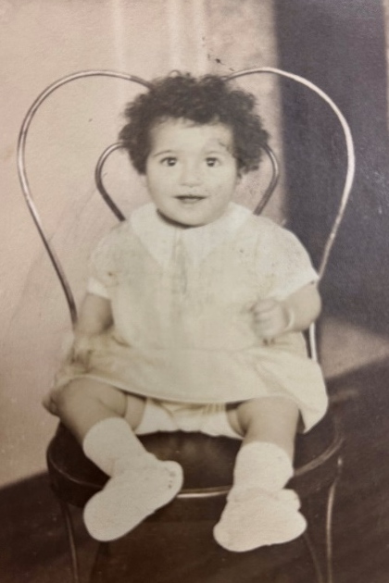
Clara at the age of one.

Anna: Clara, how did experiences such as the Armenian Genocide, displacement, and other hardships shape your family's values, identity, and outlook on life?

Clara: The missionaries did something wonderful for my parents during a time when they needed the Lord most. They taught them all about the Bible and all about the Lord. I heard that the missionaries were trying to learn Armenian, and some of them would say Armenian words, and the children would laugh at them because they wouldn't pronounce them exactly right. But they were wonderful people, and the love of the Lord that they gave these children was the main thing. My parents never, never said, “Why, Lord?” They accepted whatever they had and prayed constantly, and I think their faith is what kept them going through all those years. My mother continued that faith by teaching us as children, growing up, that you don't look at the negatives; you look at the positives. We thank the Lord that the missionaries were there to save them.

Anna: What role did faith play in helping your family endure the challenges during their journey and while establishing a new life in America?

Clara: No matter where we lived, whatever church was nearby, we went there because, at that time, we had no Armenian church in Washington. My mother would say, “Lets go to this church,” and we would go to a Methodist church, Presbyterian church, or Baptist church. We all had the love of the Lord right from the beginning because my mother always told us stories from the Bible. We were very fortunate to have a loving mother who would rather spend time with us than worry about her work. She would do her work late at night just to be with her children and to guide us to become who we are today. My mother also always made sure that we had an education, and she bought this little book for me with all the presidents in it.
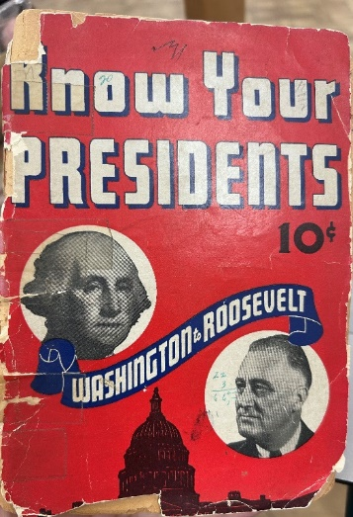
Clara’s book Know Your Presidents.

My father was always fair and kind. He was always helping others. Soon after he came to Washington, he opened a restaurant on M Street in Georgetown. If anyone was hungry, he would give them food free of charge. When the World War I veterans came to protest in front of Congress, they slept in tents along the banks of the Potomac River. My father provided them with free meals. Every day at noon, he served them lunch so they would have something to sustain them while they were in Washington.

My father’s restaurant, “Arthur’s,” served American food. People would come, and they would play the guitar. Back in those days, Gene Autry was very famous. So, there would be music at night at the restaurant. It was a happy place.

Interestingly, in his restaurant, my father never gave out cigarettes or matches like most restaurants did. Instead, he gave out chewing gum with his restaurant’s name on the wrapper. I think it was Wrigley’s. He didn't smoke, but he did like his wine. My parents always had wine at the table every night.

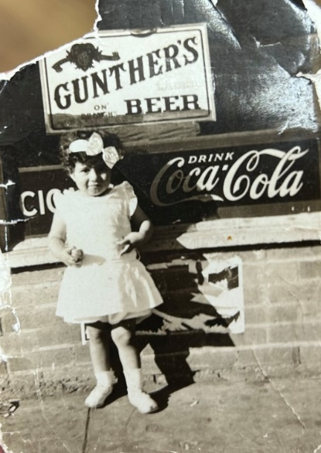
Clara, in front of her father’s restaurant.

Later, when the building that housed my father’s restaurant was torn down, he moved into the hotel business. When my third sister was born, my mother said, “I think it's time that we should move into a home.” When we were living on Mt. Pleasant, up on 16th Street, we had 15 government workers living in our house. My job was to pass out the linen and clean up the house from top to bottom. We had three floors, and we lived on the first and the ground floors.

My father loved this country. He kissed the ground when he came to this country that saved him. He volunteered his service with Civil Defense. At night, he would go by bus to an airport, airplane factory, or helicopter factory outside of Washington. He would also go out at night on 16th Street and make sure all the shades were down. They had gas masks and all the equipment and everything. I would say to him, “Can I go with you, Daddy?” And he would say, “No. It's too dark.” He would return late at night and continue working at his hotel business.

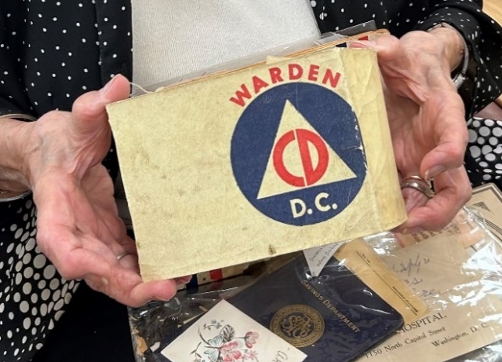
Clara’s father’s DC Warden Arm Band

My mother also did her service with Civil Defense. I have a certificate showing that she donated over 500 hours helping the World War II effort. I also have the ration books that they gave out during that time.

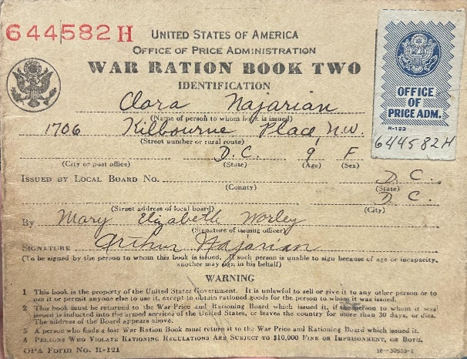
Clara’s War Ration Book.

Later in life, when my father was working at the U.S. Department of Health, a coworker asked him, “How come you, a foreigner, have a better job than I do?” And my father -- who was so kind! -- replied, “Because I have common sense, and you don't.”

Anna: Is there anything else you would like to add about your childhood that I haven’t asked you about?

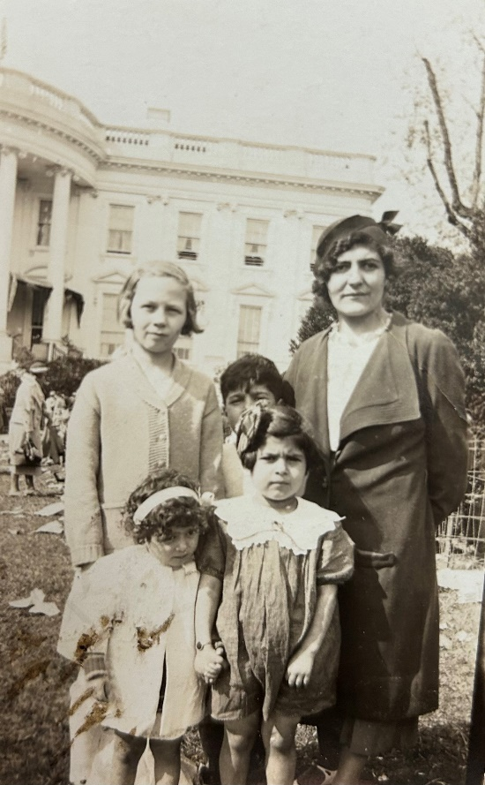
Clara’s family at the White House Lawn on Easter Sunday.
Clara: Growing up, I remember going to the White House every Easter. In order to go in, an adult had to have a child with them, or else they were not allowed to enter. And my cousin would say to me, “If you give me 5 cents, I'll take you in!”

Throughout the years, we always went, and I remember President Roosevelt, as well as Frist Lady Eleanor Roosevelt, coming out when we were kids. President Roosevelt would stay up on the balcony, and Mrs. Roosevelt would come down. I remember her shoes. She had shoes that laced up, and this made us laugh because my mother always wore high heels.

Anna: How did your family become involved in the Armenian church community in the US, and what contributions have they made to helping build and sustain the church over the years?

Clara: We didn't have an Armenian church in Washington. But my father always helped everyone: whenever there was a gathering with Armenians, he would always be the one to do the shish kebab. He would cut the meat and prepare it for all the picnics that we used to have together. He volunteered every time. At that time, the leg of lamb was only five dollars!

My mother and all the relatives were a small community, but they did everything together back in the 1930s and 1940s. Then, of course, my father passed away, and my mother ended up moving down to Miami, where two of my sisters lived. That's where they were going to retire. Whenever my mother came up to Washington, of course, she always stayed with me. She would come to St. Mary's and attend Dr. Kumkumian’s classes. He would teach the Bible, and she would add on to what he taught. She read the Bible at home every morning and every night.

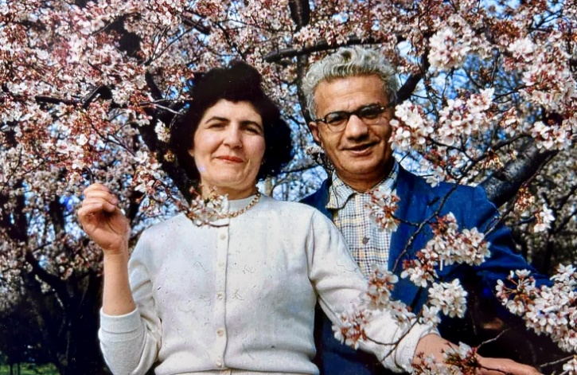
Clara’s parents in Washington, D.C.

My own family would go to church every Sunday. My husband, Jack Andonian, is from Lawrence, Massachusetts, and his family was very active up there, and he helped build the church there.

When I graduated from school, I went to work for the State Department for six years. I let them know that I was Armenian, and in a way, my story was an inspiration to many of them -- we are people with hope in our lives and love for the Lord. This is how we survived. And without the Lord, nothing happens. He is in control.

When my husband and I were about to get married, I was getting ready to go to Hawaii for the signing of the peace treaty with Japan during the Eisenhower administration. When Jack proposed to me, I said, “Well, I'll have to think about it,” because I was already signed to go, and you couldn't be married, engaged, or involved with anyone, because you could be compromised. I decided that life has to go on, and I wanted to have a family. So, I said yes. I was able to continue my work after that, and I always entertained my bosses in my home. In fact, they ended up coming to St. Mary's bazaars, too.

My husband Jack would always tell our three sons – David, Aram and Levon, “No matter what time you come home at night, we leave for the church at 9 o'clock every Sunday.” We were always the first to come and the last to leave. He served the church as much as I did right from the beginning, when the doors opened in 1953.

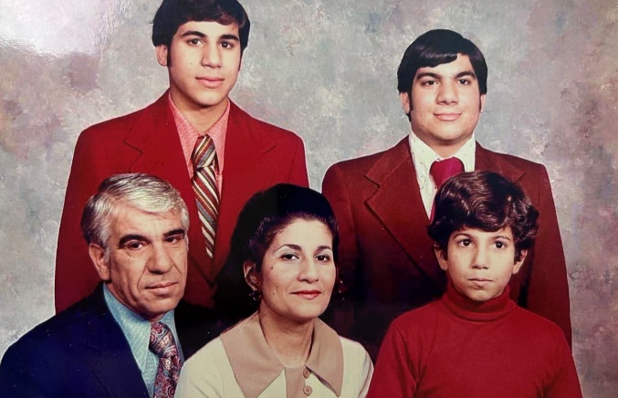
Clara, her husband Jack, and their three sons.

We were the first to walk into St. Mary’s Armenian Church in Washington, DC. Our relatives, who lived around the church, looked around the area and decided on this location, even though it was just a basement at the time. In 1954, with 250 families, the unfinished Church was purchased (the new church building was completed in 1963 after several years of fundraising). My husband served on the Board of Trustees, and so was my father-in-law. Our main church hall was what is now the church’s ground floor. The Parish Council's room was where the freezer is now.

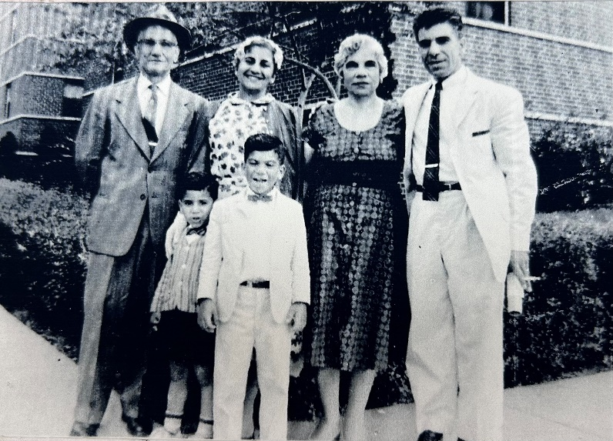
Clara, top row, second from left, with her husband Jack, children and parents-in-law.

My husband made the first altar for St. Mary’s Armenian Church. He built it in my parents’ basement, and I had to get the measurements for him from the Bible. My husband also always did all the framing, and a lot of his frames are still here. He had made gold crosses for every window, and I did keep one of the crosses when the church was renovated. My husband also wanted them to put the choir up above where we are now. He had this vision, and it eventually came true!

There were fewer than 100 people coming to church on a regular basis during that time. Then, of course, everyone who came to Washington for work ended up coming to the church. People came from all over: Harpoot, Marash, Ayntap, and other places. We all spoke Western Armenian. When the church was built, everyone came together, and it was just a very happy and welcoming period of time. Later, whoever came from Armenia during the Soviet time, we welcomed them here too.

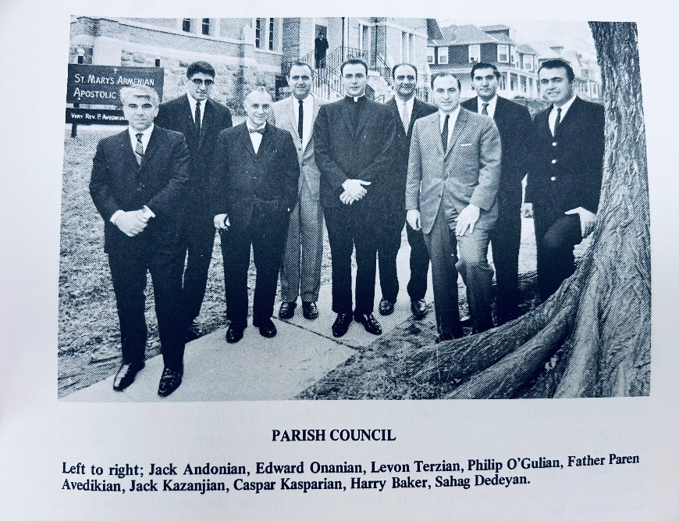
St. Mary’s Armenian Church’s Parish Council

I particularly remember Nishan Hintilian, who was a major benefactor and the godfather of our church. St. Mary's Church is named in memory of his child, Mary, who had passed away. The upstairs wasn’t built until our first priest, Father Karekin Kazanjian, came here from Bolis in 1963. He eventually became the Patriarch of Istanbul and, later, of Jerusalem. My husband Jack and Father Karekin had birthdays a week apart; they called each other brothers and were very close. Father Karekin stayed with my family until we found a place for him to live.

In 1967, Father Paren Avedisian became our priest, and my family hosted him until he found a place. Between 1969 and 1975, our third priest was Bishop Papken Varjabedian. After him, of course, came our dear Der Vrtanes Kalajian, who started as a visiting pastor in 1976 and officially assumed the pastorate in January of 1977. Finally, our current priest, Father Hovsep Karapetyan became our priest in April of 2007. My husband and I hosted many of St. Mary’s priests at our house. That is why I feel that my home was blessed, and all my children were blessed, because God was always there.

In those early days, the priests would hold the Sunday service, and they visited all the sick. Karekin Kazanjian’s sister Berjouhe and niece Ani Law moved here too, and when the top of the church was being built, Ani helped lay one of the bricks next to the cornerstone of the church. I have a lot of happy memories of that time.

The Armenian Sunday School opened right after St. Mary’s was built. I was a Sunday School teacher for the nursery children and helped raise many children. For perfect attendance, we used to give out little badges. Every year, they would attach another little year onto it. Ann Kavookian was also one of the Sunday School teachers. She never married, but all the children here were her children, and they loved her dearly. Her mother and all the other ladies were the ones I worked with in the kitchen, and I learned their ways of doing things. Of course, I was their youngest member. I thank them for all that they taught me.

Among my Sunday School students, I had Dr. Edward Nubar Bodurian and Dean Shahinian. For their homework assignments, I would say, “Just come next week with one sentence of what you remember from what I taught you.” They would come back with a whole page written out! They were my prized students. They were all boys, with only one girl in my class at that time. You knew who was from a family that had faith, and you knew who was from a dysfunctional family. You guided them, and you showed them that you loved them too.

Later on, my husband and I joined the choir. I've been singing in the choir ever since. This photo (below) was taken at my son David's baptism. He was the first to be baptized at St. Mary’s Church.
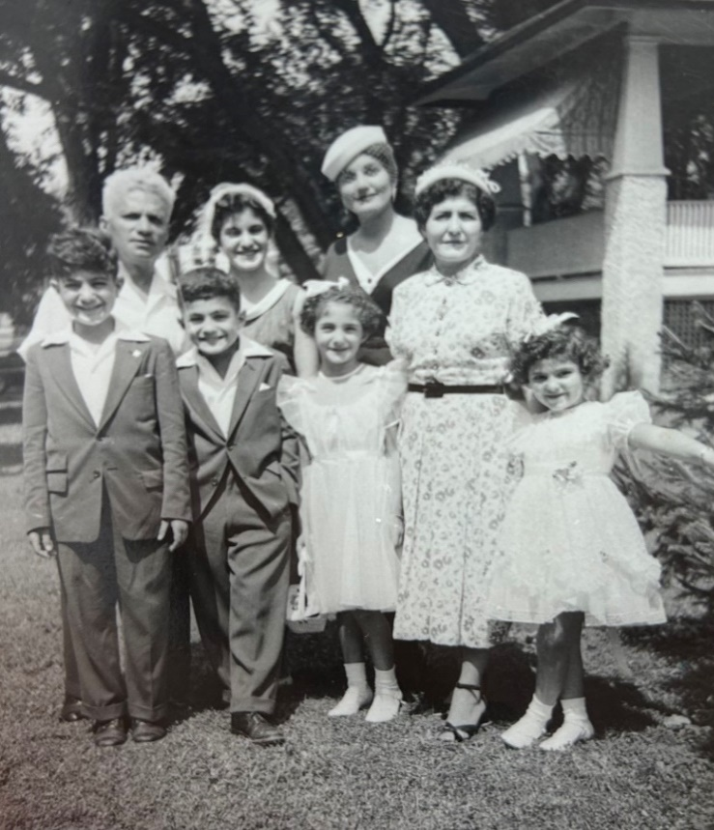
Clara’s mother and siblings, at Clara’s son David’s baptism, 1954. Washington, DC.

Fast forward to today, my oldest grandchild, Sophia, now attends St. Mary’s Sunday and Armenian School. She doesn't call our church “St. Mary's.” She says, “I'm going to Armenia every Sunday.” This is because everybody speaks Armenian here.

Anna: What lessons, traditions, or stories passed down through generations do you hope future generations of this church will remember about your family's journey, faith, and service?

Clara: I have three sons, six grandchildren, and three great-grandchildren. I've taught my children that “This is the day the Lord has made; We will rejoice and be glad in it.” That is Psalm 118:24. I say that every morning, and I taught my children and my children's children and friends. I'll say, “What does Grandma say, or what does Auntie Clara say?” Right away, they know exactly what I mean!

My granddaughter Lauren always heard me say that. When she was having her first child, she asked me to write it on a huge cardboard. At Christmas time, she framed it and hung over the baby's crib. She also printed and framed the word “hokis” (my soul) that I always use. I passed it on to them, and hopefully, they'll pass it on to their children.

Anna: Of the many amazing foods that you taught everybody at this church to make during the festival, what is your favorite?

Clara: Well, there are many, of course. I think my favorite is kurabia -- I loved it ever since I was a child. Fifty years ago, when America had its bicentennial, the Smithsonian asked us to be a part of it. They wanted to put out kurabia at the Smithsonian, and they asked for 3,000! I said, “Okay, I will do that.” And I took one month to make 3,029 of them! I also love making pilaf. I always make the sign of the cross when I cook or bake.

At Christmas time, we had a Christmas tree at the Smithsonian, and we put our Armenian lacework on it instead of the usual ornaments. My friend Jean Sayian and I also did a cooking demonstration on how to make string cheese and bourma. About 5,000 people came to watch, mostly non-Armenian visitors. They asked, “Well, where can we buy the ingredients?” And we kept saying to them, “Whatever town you're from, just go to any Mediterranean store or any store that sells things that are different from all the others. Just look for those stores.”

June 20, 2026
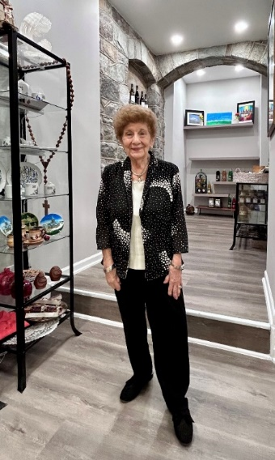
Clara Andonian at St. Mary’s Gift Store.

